Annual Financial Report 2023
iMPACT direct

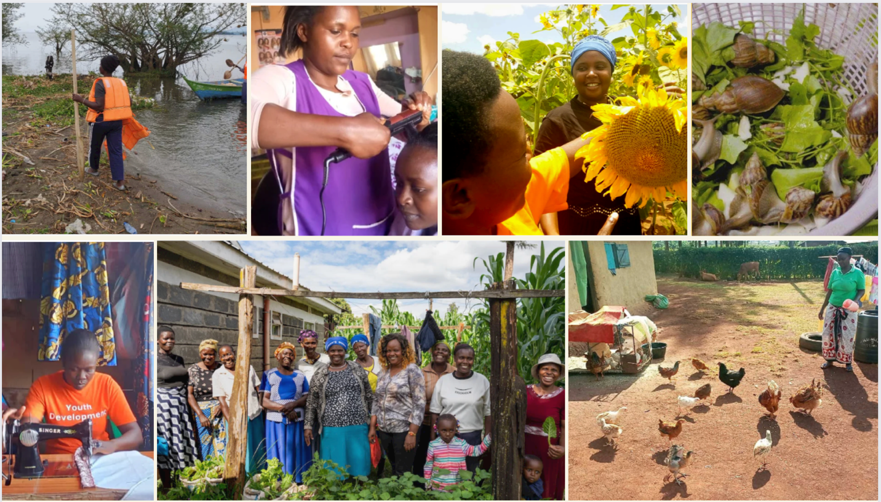

Financial Year: 2023
Ending at: 31.12.23
Date of approval: 22 February 2024

Organisational details
Name: iMPACT direct Foundation
Date of foundation: June 12, 2020
Bank account №: NL13 ABNA 0105 5215 82
Chamber of Commerce №: 78278937
RSIN №: 86 13 28 991

Board members
Dieuwertje Damen Chair
Richard Yeboah Treasurer
Nicky Wakou Secretary
Wanjiku Jean Munyaka Board Member

Find all details here: https://impactdirect.eu/about

Statement of Comprehensive Income for the year ended 31.12.2023
INCOME |  | 31-12-2023 | 31-12-2022
Donations | Crowdfunding | 8,258 | 4,248
Donations | Partner Organisations | 2,873 | 1,984
Donations | Grants | 116,030 | 62,475
 | Interest | 0 | 22
TOTAL |  | 127,161 | 68,728
EXPENDITURES
DIRECT COSTS | Professionalisation Grants to NGOs | 22,011 | 0
Projects | COSDEP: Water Pans for Sustainable Farming | 5,653
 | HCF: Snail Farming | 7,040
 | IPI: Ecologia Youth Trust project | 58
 | IPI: Girls Reclaim their Lives | 9,810
 | KAF: Young Women master Tailoring | 2,500
 | OLCAP: Zero Hunger through Mixed Farming | 8,060
 | Pinasol: Young Solar Electricians | 4,747
 | Pinasol: Youth Employment Centre | 7,497
 | TAI: Women Sunflower Business | 6,236
 | RSS: Literacy School continued | 146
 | VAO: Innovative Women Farmers | 746
 | WA-WA: Beauty Parlour | 7,800
 | WA-WA: Boats for Fisherwomen | 6,703
 | total project costs | 66,995 | 58,893
Programme costs | Visibility | 4,101 | 4,568
 | Access to funding for NGOs | 5,377 | 0
 | Training, Sharing Expertise & Matchmaking | 2,685 | 0
 | Trust-Based Partnerships | 12,132 | 7511
 |  | 24,295 | 12,079
Subtotal direct costs |  | 113,301 | 70,972
INDIRECT COSTS | Management costs | 4,612
 | Fundraising costs | 3,178 | 1,141
 | Administration costs | 1,090 | 480
 | Other costs | 594 | 425
 | Interest on debt | 120 | 12
 |  | 9,595 | 2058
TOTAL |  | 122,896 | 73,030
Balance Income and Expenditures |  | 4,265 | -4,302

2. Statement of Financial position for the year ended 31.12.2023
ASSETS |  | 31-12-2023 | 31-12-2022
 | ABN AMRO | 4,981 | -84
 | Bunq | 0 | 2,597
 | Curo | 0 | 50
 | Paypal | 4 | 0
 | Wise | 478 | 0
 | Grants receivables | 25,140 | 1,761
TOTAL Assets |  | 30,602 | 4,324
LIABILITIES | Professionalisation Grants Payable | 2,250
 | Projects payable | 8,082 | 1,587
 | Other payable | 13,268
 | Debt payable | 3,000 | 3,000
 | Accrual
TOTAL liabilities |  | 26,600 | 4,587
Financed By | General Reserve | -263 | 4039
 | Returned earnings | 4,265 | -4,302
Total Liabilities and Net Assets |  | 30,602 | 4,324

3. Explanation to the state of income and expenditures

INCOME
Income comprises contributions by individual donors through crowdfunding, partner’s contributions, and grants from various donors. The total income in 2023 was €127,161. Together with an amount of €25,140 committed grants, but to be transferred in 2024, the total fundraised amount is €152,301.

Crowdfunding
€8,258 was donated through our crowdfunding platform to specific projects or to be divided over all open projects.

Support by partner organisations and middle donors
Donations from main partners received are:
- YouBeDo: €1,773
- Foundation for Family Giving: €1,000
- Hogeschool Arnhem Nijmegen (HAN University of Applied Sciences): €100
Totalling: €2,873

Grant donors
Main grants received are:
- SAS-P Foundation: €45,000
- Stichting Overal: €39,309
- AFAS Foundation: €10,742
- Stichting De Hoorn: €4,667
- Wubbens Foundation: €1,000
Grants that we have fundraised for, but were directly sent to our partner-NGOS include:
- Wilde Ganzen: €12,312
- Haella Foundation: €2,500
Totalling: €116,030

In addition, €25,140 will be transferred in 2024.

Besides we received support in kind from two main sponsors:
- Web Development (CAPREA Media) (worth €7,500)
- Google email, Drive and Ads (worth €72,000 per year)
As this is a budget that we have access to in kind, but it isn’t received in our account. The state of income and expenditure therefore doesn’t display these amounts.

COSTS
Expenditure comprises Project costs, Professionalisation Grants to NGO, expenses incurred directly for programme activities, and indirect costs to manage and organise our work.

RATIOS |  | 2023 | 2022
Direct costs | Project + Professionalisation Grants to NGOs | 72% | 81%
 | Programme Costs | 20% | 17%
Indirect costs | Fundraising costs | 3% | 2%
 | Management costs | 4% | 0%
 | Administration costs | 1% | 1%
 | Other costs | 1% | 1%
TOTAL |  | 100% | 100%

From every project donation, 5% is for indirect costs. To be able for all programme and indirect costs, we rely on additional programme or core funding.

iMPACT direct maintains low costs with an online office, and with a small team of paid consultancies based in Africa, and paid volunteers in Europe.

Board / Audit Committee
Board members and the audit committee are not paid for their work but may receive compensation for costs made that are essential for their work (e.g., for occasional travel expenses). Such costs will be reported in our financial reports. In the financial year 2023, €33 was used to this effect.

4. General Explanation
iMPACT direct believes that development cooperation can create more impact if we distribute funds and decision-making power more fairly. That is why we connect a large group of donors to underfunded African non-profits that have successful local solutions. When local experts and the community members they work with can decide over their budgets, donations reach more people and create more impact.

Our mission
To contribute to the impact of locally-led NGOs that successfully contribute to economic development / poverty reduction, food security and/or advanced education in low-income countries or to people living below the poverty line; to contribute to strengthening the position of civil society; and to contribute to an equal collaboration between northern and southern organisations; and all that relates to this or facilitates our objectives.

Our strategies
With our approach we want to contribute to a system change in the development sector, for locally-led NGOs to access and decide over more than the current 2% of the direct aid budget (for sources see www.impactdirect.eu/toc).

iMPACT direct supports local NGOs to become self-sustaining, as follows:
1. Visibility of locally-led solutions by showcasing the work, expertise and results of the NGOs and their stories at our website, at socials and in (online) events.
2. Access to unrestricted funding. We support NGOs on their ambitions and plans, with project funding – 95% of donations made to project donations goes directly to southern-based NGOs – and a professionalisation grant (i.e. core-funding).
3. Training, Sharing Expertise & Matchmaking by working on the 5 elements of a Healthy Nonprofits and Financial Sustainable Organisations in all our actions. We provide thorough support to our partner organisations and make expertise accessible online for any small locally-led NGO.
4. Trust-based partnerships from the first partner-visit on during the entire 3 years of the partnership. This allows for open conversations, getting to the best possible impact together.

To provide trust and transparency, iMPACT direct provides:
● Barometers per raised donations per project on our website.
● We provide a monthly update overview to our partner-NGOs, so they can track donations to their projects.
● NGOs provide financial plans and reports (checked by our team) on our website to donors.
● Quarterly, our Financial Administration is checked by our Finance Committee.
● An Audit Commission checked the annual financial report.

General Principles
The financial annual report is in accordance with the guidelines for fundraising organisations, as published by the Board for Annual Reporting (guideline 650). No changes took place in this financial year.

Principles for valuing Assets and Liabilities
Assets and liabilities are valued at cost price or manufacturing cost. In case no specific value is mentioned, valuation is done at cost price.

Liquid assets
Liquid assets are valued at nominal value. Liquid assets are at free disposal for the foundation.

Reserves and funds
The amount of 'general reserve’ shows the difference between possessions and debts. The amount is at free disposal for the foundation and should be spent on the foundation’s objectives.

Designation Funds
It is called a designation fund, when third parties donate part of the assets for a specific expenditure. In this case it is not the board who decides on the expenditure but the donor. The amount is earmarked and planned but not yet spent.

Principles for the state of income and expenditures
The difference between income and expenditure is €4,265.

Constitutional regulations for the expenditures of assets and liabilities
The result designation has been divided in accordance with the state of income and expenditures, as shown above. No condition concerning the result designation has been included in the constitution of the foundation. The board approves the result designation by adopting the annual financial report including the result designation.

Events after Balance Date
No events happened after the balance date that needs to be mentioned here.

Adoption and approval
This annual financial report has been adopted and approved by the board on 22 February 2024.

Since no assignment is issued to an accountant, a declaration from an independent accountant is missing. A declaration from the audit commission is attached.

Agreed and signed:

Dieuwertje Damen Richard Yeboah Wanjiku Jean Munyaka
Chair Treasurer Board Member

